**NAME – SOMDEV SHEEL**

**SUBJECT – SQL**

1. **Create a table “Station” to store information about weather observation stations**:

CREATE TABLE Station (

ID Number PRIMARY KEY,

CITY CHAR(20),

STATE CHAR(2),

LAT_N Number,

LONG_W Number

);

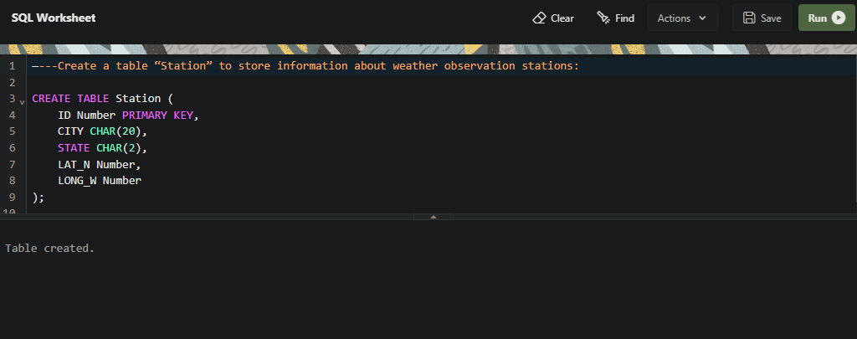

1. **Insert the following records into the table:**

INSERT INTO Station (ID, CITY, STATE, LAT_N, LONG_W)

VALUES (13, 'PHOENIX', 'AZ', 33, 112);

INSERT INTO Station (ID, CITY, STATE, LAT_N, LONG_W)

VALUES (44, 'DENVER', 'CO', 40, 105);

INSERT INTO Station (ID, CITY, STATE, LAT_N, LONG_W)

VALUES (66, 'CARIBOU', 'ME', 47, 68);

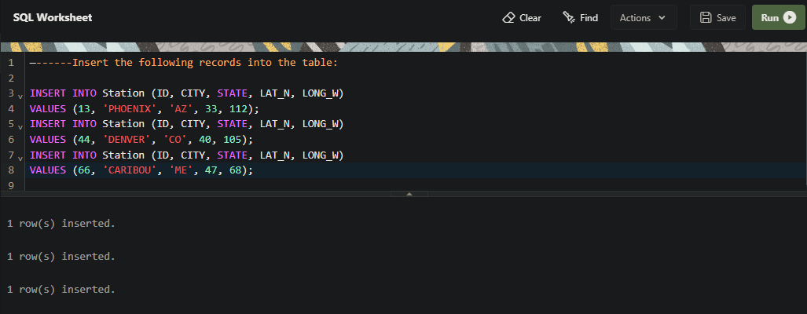

1. **Execute a query to look at table STATION in undeﬁned order**.

SELECT * FROM Station;

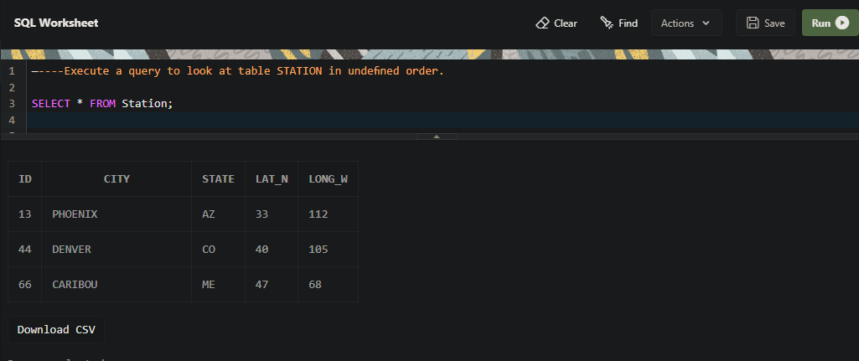

1. **Execute a query to select Northern stations (Northern latitude > 39.7).**

SELECT * FROM Station WHERE LAT_N > 39.7;

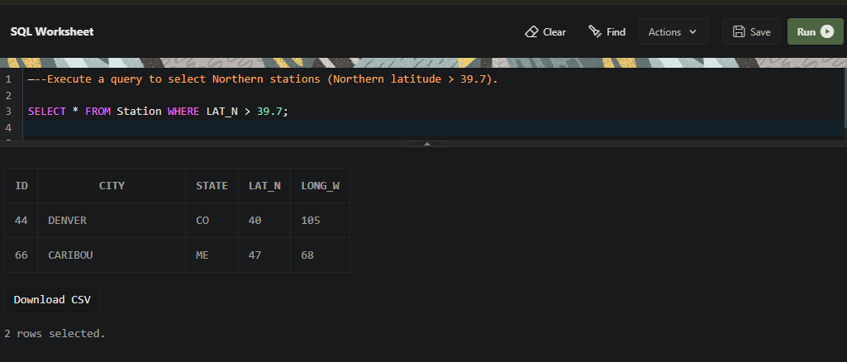

1. **Create another table, ‘STATS’, to store normalized temperature and precipitation data:**

CREATE TABLE STATS (

ID Number,

MONTH Number,

TEMP_F Number,

RAIN_I Number,

PRIMARY KEY (ID, MONTH),

FOREIGN KEY (ID) REFERENCES Station(ID)

);

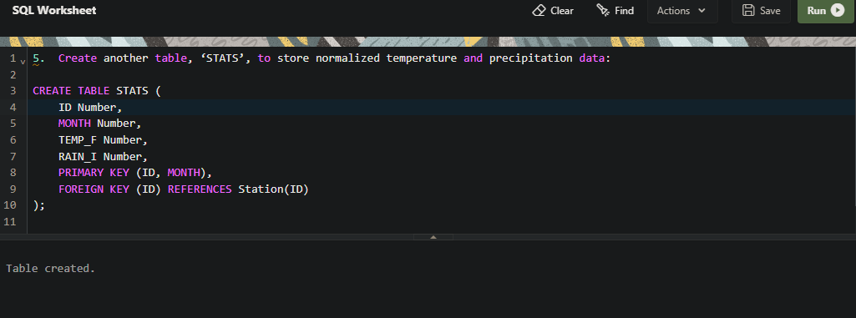

1. **Populate the table STATS with some statistics for January and July:**

INSERT INTO STATS (ID, MONTH, TEMP_F, RAIN_I)

VALUES    (13, 1, 57.4, 0.31);

INSERT INTO STATS (ID, MONTH, TEMP_F, RAIN_I)

VALUES    (13, 7, 91.7, 5.15);

INSERT INTO STATS (ID, MONTH, TEMP_F, RAIN_I)

VALUES    (44, 1, 27.3, 0.18);

INSERT INTO STATS (ID, MONTH, TEMP_F, RAIN_I)

VALUES    (44, 7, 74.8, 2.11);

INSERT INTO STATS (ID, MONTH, TEMP_F, RAIN_I)

VALUES    (66, 1, 6.7, 2.1);

INSERT INTO STATS (ID, MONTH, TEMP_F, RAIN_I)

VALUES    (66, 7, 65.8, 4.52);

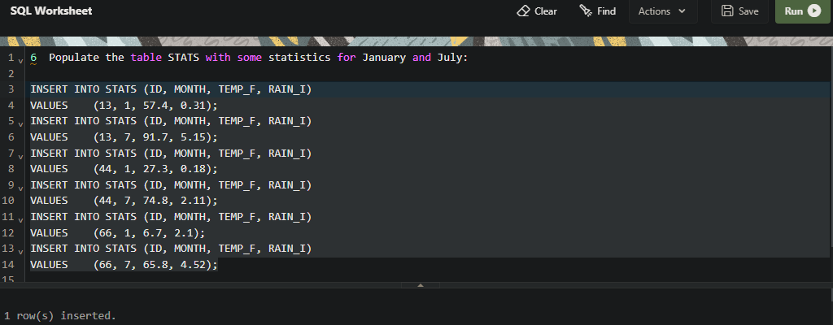

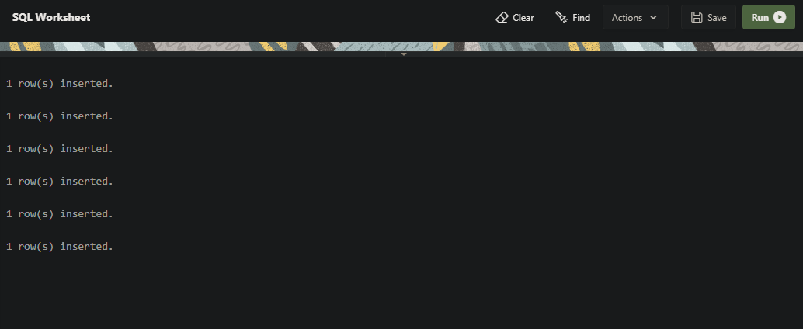

1. **Execute a query to display temperature stats (from STATS table) for each city (from Station table).**

SELECT s.ID, st.CITY, s.MONTH, s.TEMP_F

FROM STATS s

JOIN Station st ON s.ID = st.ID;

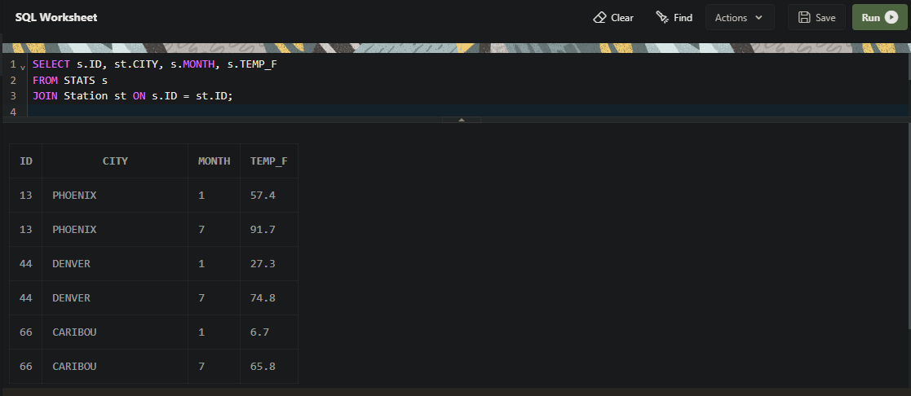

1. **Execute a query to look at the table STATS, ordered by month and greatest rainfall, with columns rearranged. It should also show the corresponding cities.**

SELECT s.ID, st.CITY, s.MONTH, s.RAIN_I, s.TEMP_F

FROM STATS s

JOIN Station st ON s.ID = st.ID

ORDER BY s.MONTH, s.RAIN_I DESC;

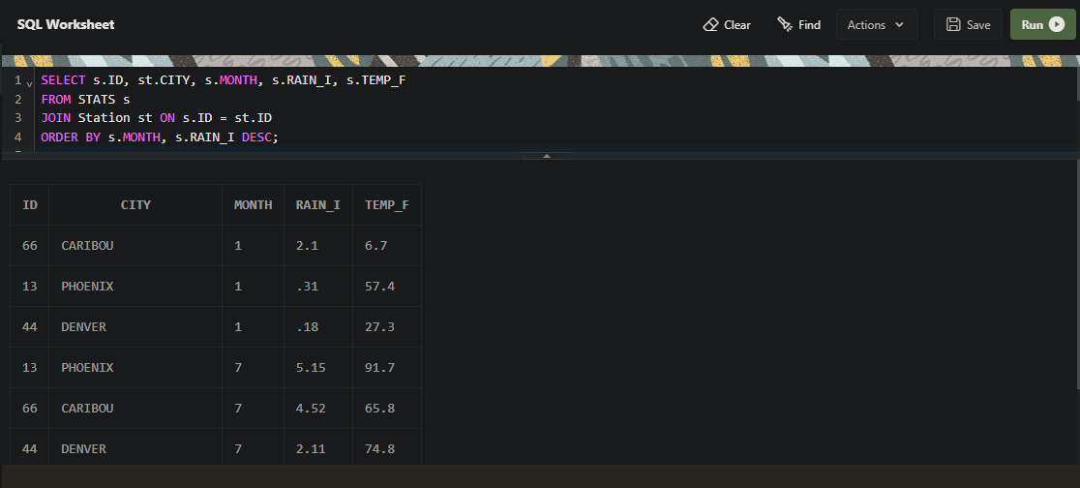

1. **Execute a query to look at temperatures for July from table STATS, lowest temperatures ﬁrst, picking up city name and latitude**.

SELECT st.CITY, st.LAT_N, s.TEMP_F

FROM STATS s

JOIN Station st ON s.ID = st.ID

WHERE s.MONTH = 7

ORDER BY s.TEMP_F;

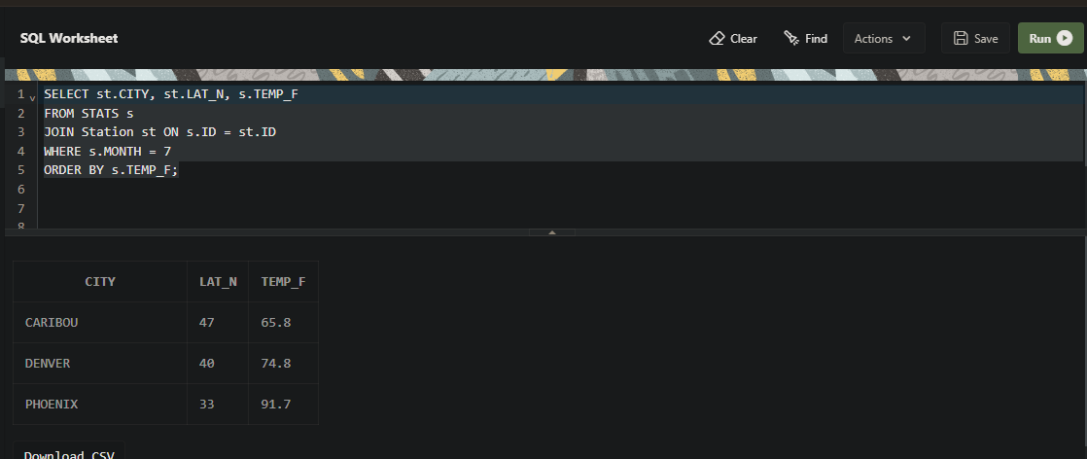

1. **Execute a query to show MAX and MIN temperatures as well as average rainfall for each city**.

SELECT st.CITY, MAX(s.TEMP_F) AS MAX_TEMP, MIN(s.TEMP_F) AS MIN_TEMP, AVG(s.RAIN_I) AS AVG_RAINFALL

FROM STATS s

JOIN Station st ON s.ID = st.ID

GROUP BY st.CITY;

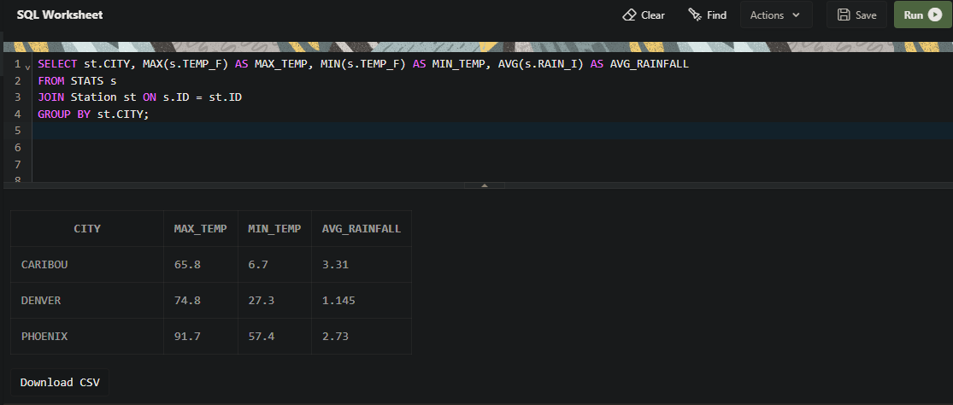

1. **Execute a query to display each city’s monthly temperature in Celcius and rainfall in Centimeter.**

SELECT

st.CITY,

s.MONTH,

(s.TEMP_F - 32) * 5/9 AS TEMP_C,

s.RAIN_I * 2.54 AS RAIN_CM

FROM STATS s

JOIN Station st ON s.ID = st.ID;

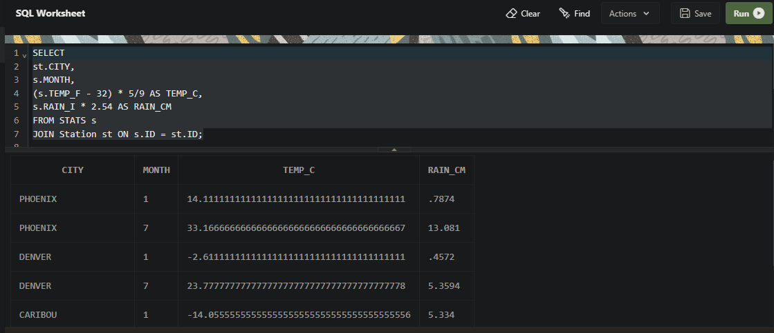

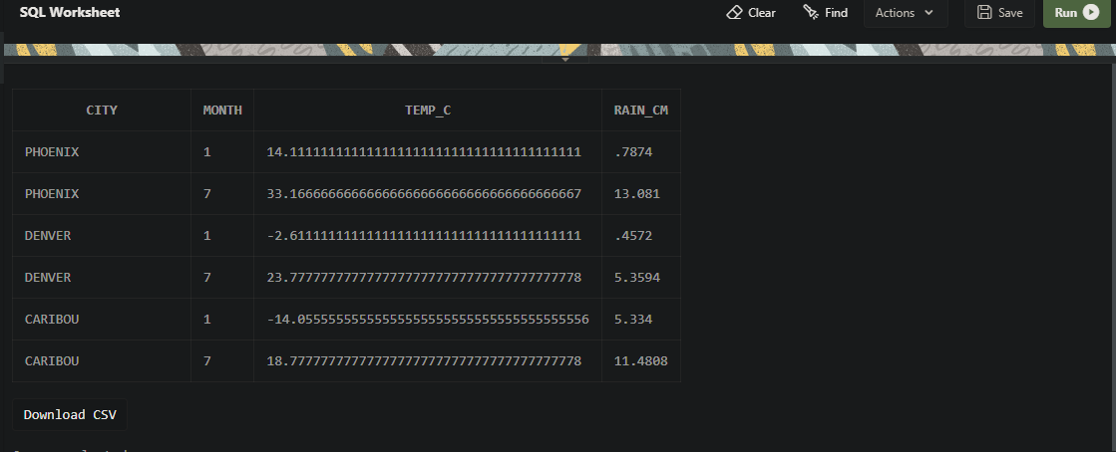

1. **Update all rows of table STATS to compensate for faulty rain gauges known to read 0.01 inches low.**

UPDATE STATS SET RAIN_I = RAIN_I + 0.01;

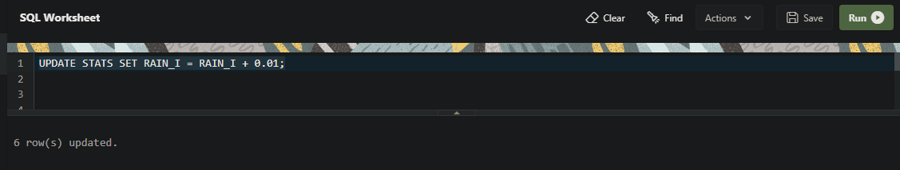

1. **Update Denver's July temperature reading as 74.9**

UPDATE STATS SET TEMP_F = 74.9 WHERE ID = 44 AND MONTH = 7;

